**Internship Report**

**TECKNIK NEST**

**Week 2**

Muhammad Abdullah (B24F0513SE021)

**BS-SE BLUE (Fall-24)**

**School of Computing Sciences**

**Fachhochschule TECKNIK NEST**

**Internship Dates: 14th June – 31st July 202**

**Task 1**

Create a mini profile for a fictional user using variables. Store the following information:

Full name , Age , Current year, Country, Hobby, Expected graduation year (calculate it from current year + 4)

Print all details in a proper sentence format.

Also print how many years are left till graduation**.**

**Output**

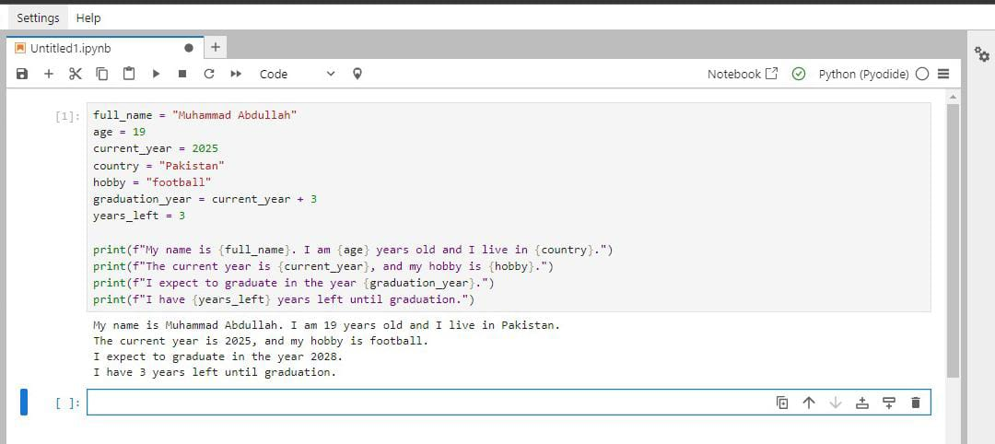

**Task 2**

Create 3 different user profiles (using variables). For each profile, include:

Name, profession, country, is_employed (Boolean)

Print their data in a tabular format using print() (not with external libraries).

**Output**

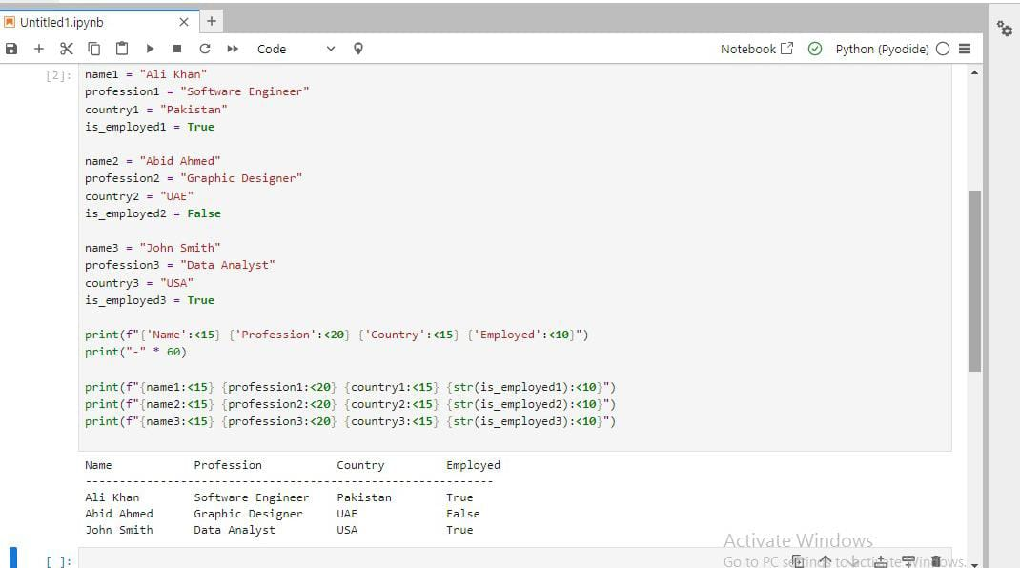

**Task 3:**

Write a program that:

Declares five different variables , Stores a different data type in each (e.g., string, integer, float, boolean, complex)

Prints their values and data types

Then, converts each variable to a different type (where possible) and prints the new types

Note: You may not be able to convert all types — handle errors or comment why.

**Output**

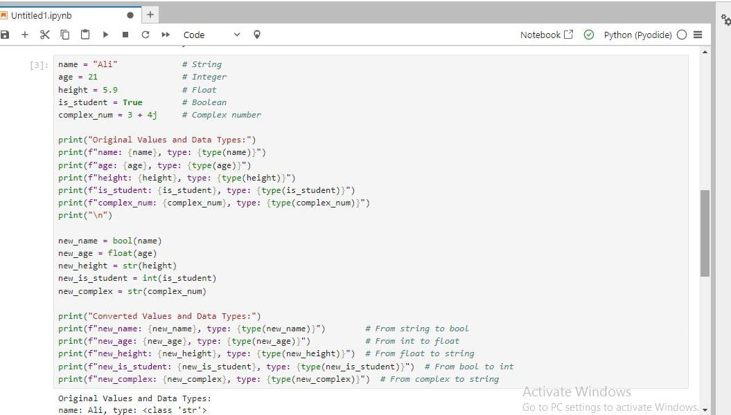

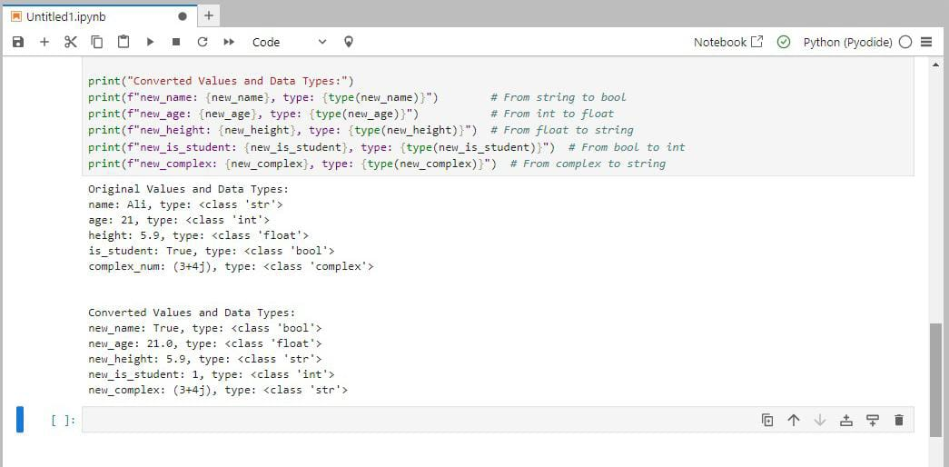

**Task 4:**

Create a data type tester:

Ask the user to input any value. , Detect and print what Python guesses its type as (use type()).

Add conditions to identify if it's likely an integer, float, or string, and print a message like:

"You entered a float!"

**Output**

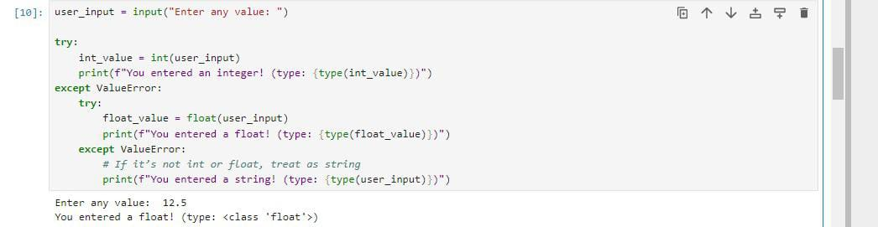

**Task 5:**

Design a command-line survey that:

Asks the user 5 different questions (e.g., name, favorite food, birth year, favorite number, favorite language)

Then prints a summary of all responses in sentence format.

Use formatting to make the output look professional (e.g., f-strings).

**Output**

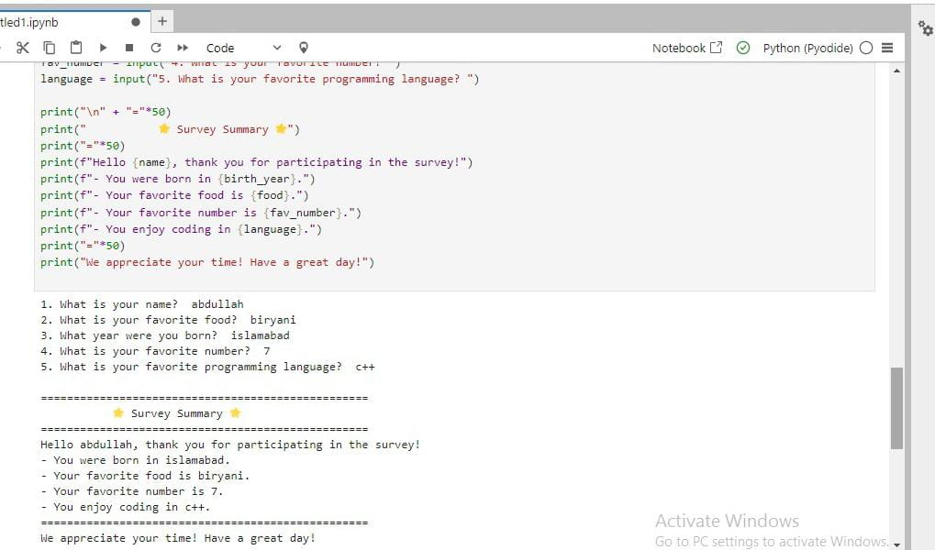

**Task 6:**

Ask the user to:

Enter their year of birth , Calculate their age (based on current year) ,Check if the user is eligible to vote (18+ years)

Display a message:

"You are eligible to vote." or "You are not eligible to vote yet."

**Output**

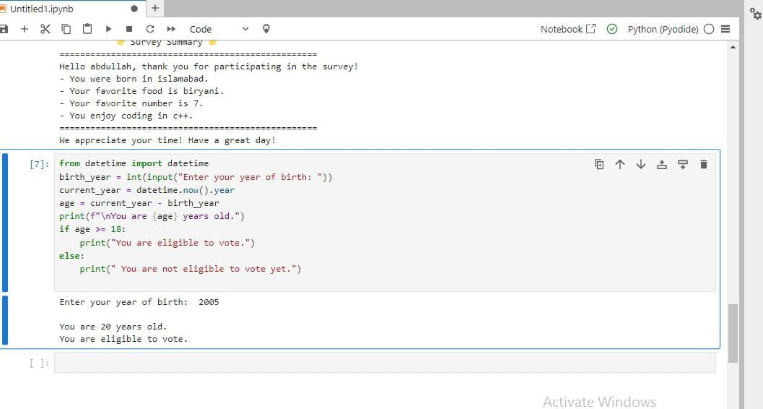

**Task 7:**

Create a marks percentage calculator:

Ask user to input marks for 5 subjects (input as strings) , Convert them to integers

Calculate the total and percentage

Print percentage along with a grade: A (90+), B (80-89), C (70-79), Fail (<70)

**Output**

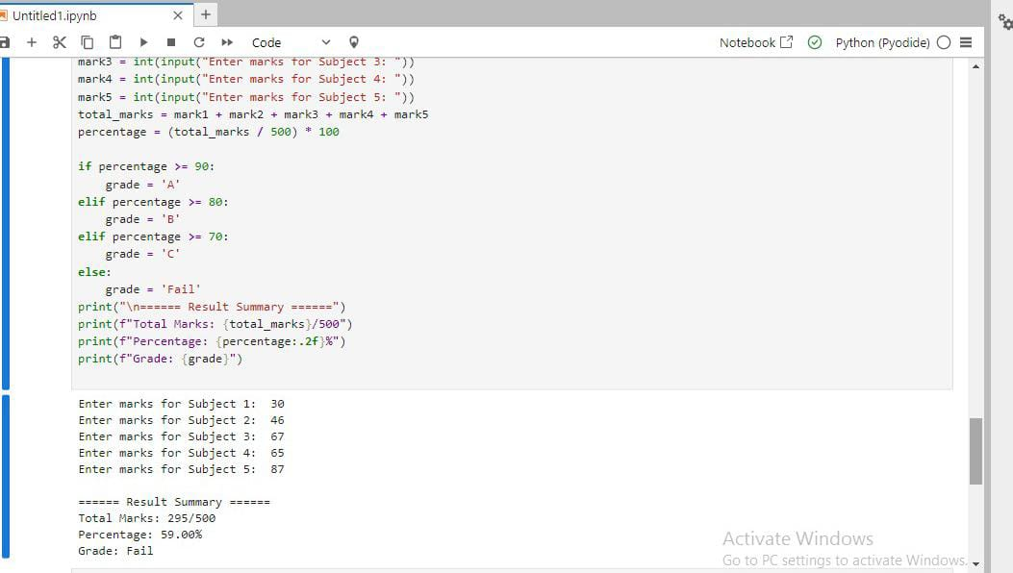

**Task 8:**

Create a temperature converter:

Ask the user to input temperature in Celsius.

Convert it to Fahrenheit using: F = (C * 9/5) + 32 , Then reverse: Ask for Fahrenheit, convert it to Celsius.

Handle wrong input types using try-except**.**

**Output**

